**Challenge 10 – ER diagram with SQL queries**

**1 point:**

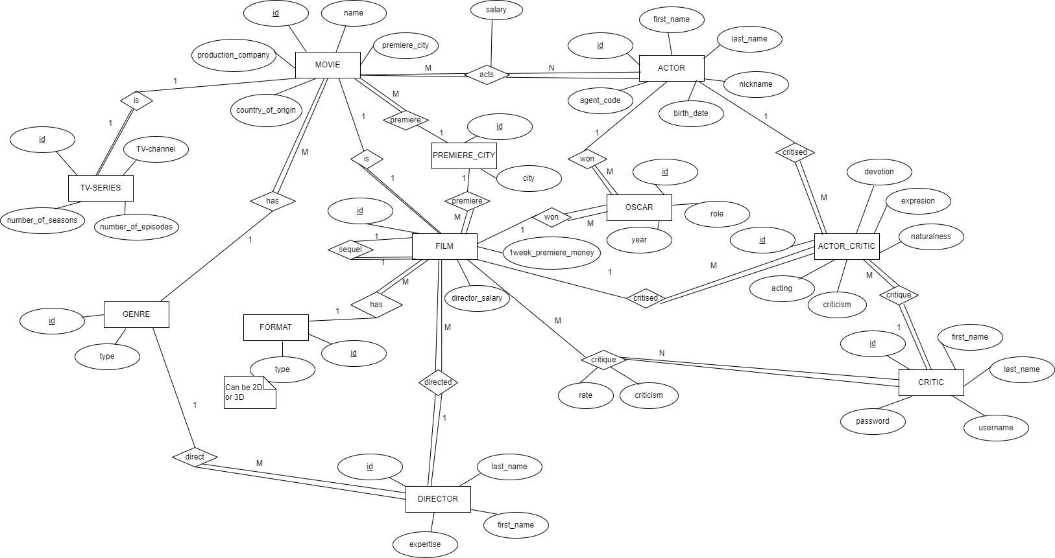

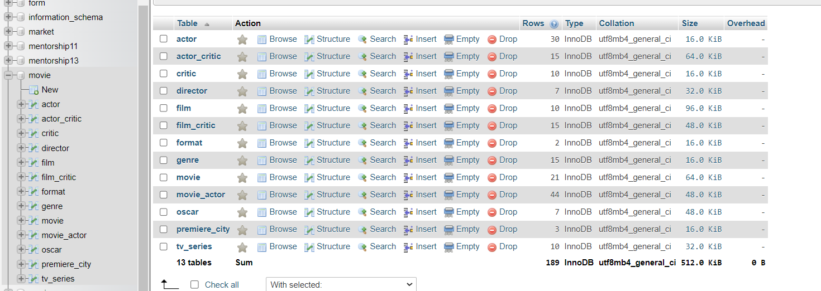

SELECT * FROM movie;

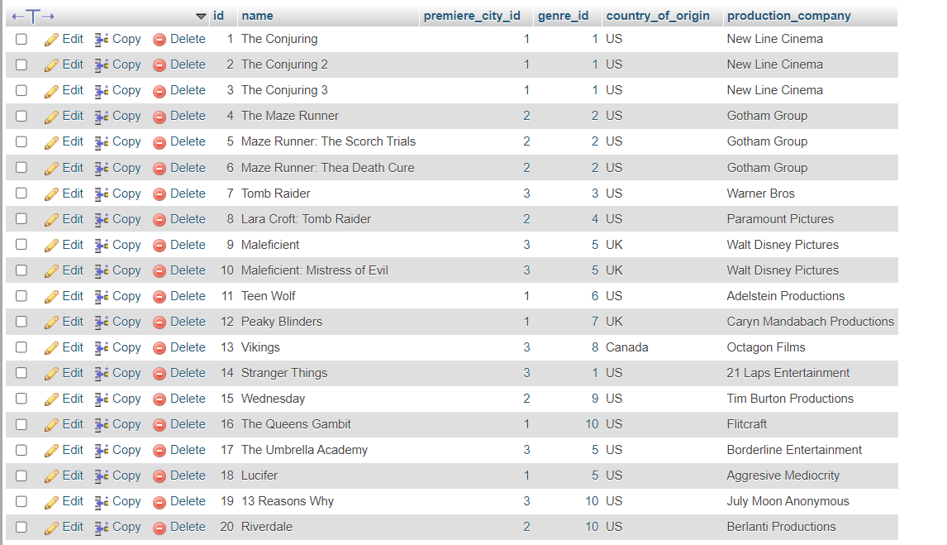

SELECT * FROM genre;



SELECT * FROM premiere_city;

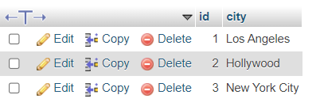

SELECT * FROM tv_series;

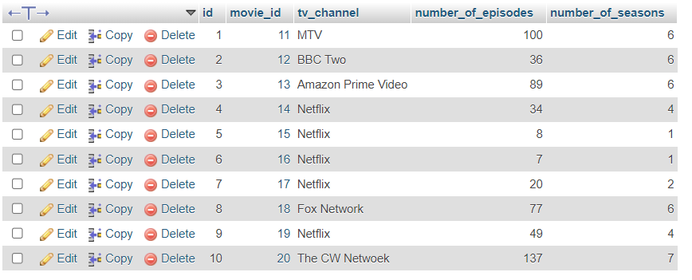

SELECT * FROM film;

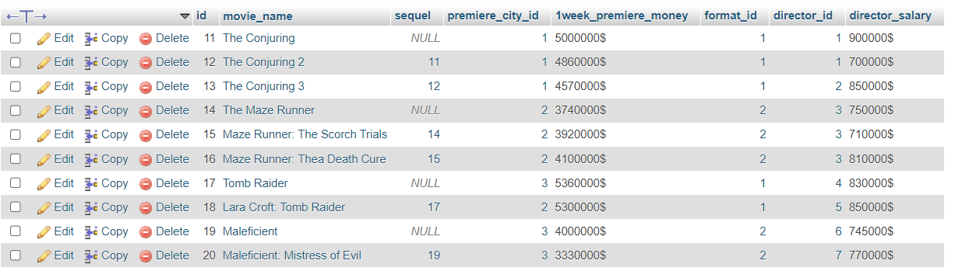

SELECT * FROM format;

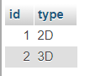

SELECT * FROM director;



SELECT * FROM actor;

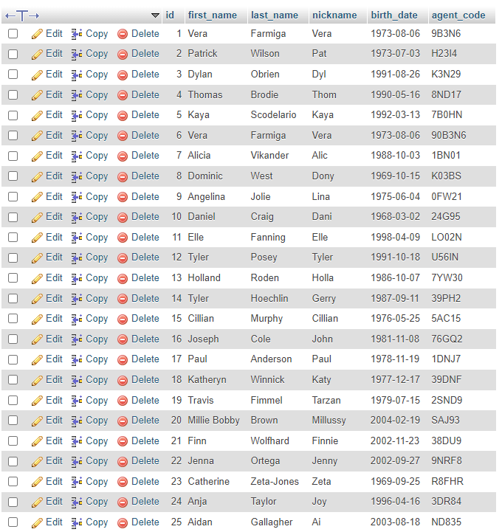

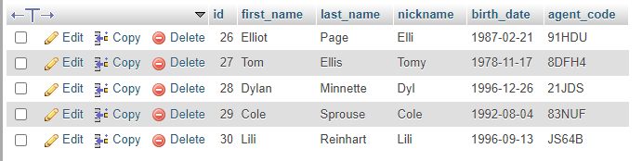

SELECT * FROM movie_actor;

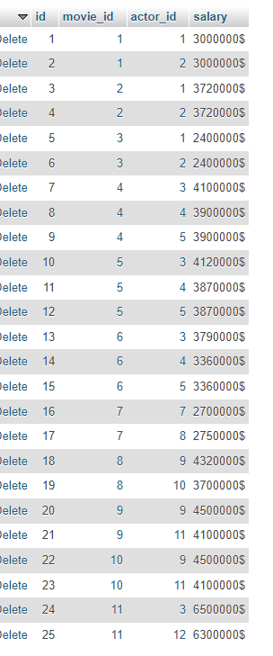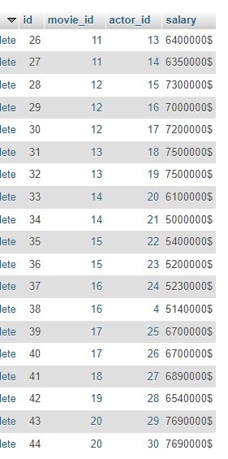

SELECT * FROM oscar;

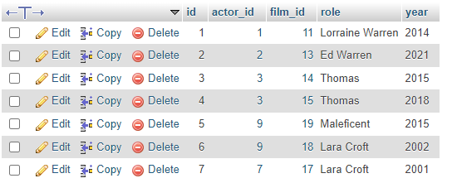

SELECT * FROM critic;

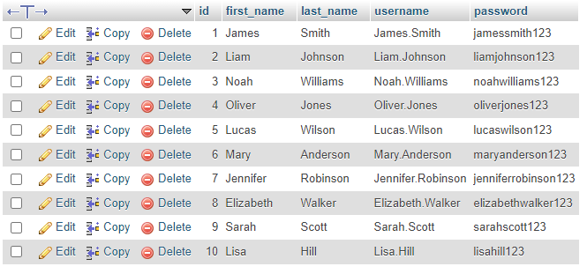

SELECT * FROM film_critic;



SELECT * FROM actor_critic;

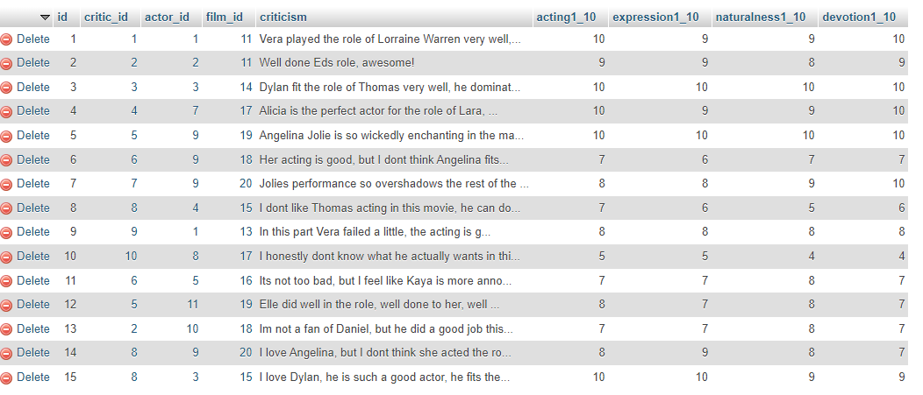

**3 points**

* SELECT m.id, m.name, pc.city AS premiere_city, g.type AS genre, m.country_of_origin, m.production_company, COUNT(ma.actor_id) AS number_of_actors

FROM movie m JOIN movie_actor ma ON ma.movie_id=m.id JOIN actor a ON ma.actor_id=a.id JOIN genre g ON m.genre_id=g.id JOIN premiere_city pc ON m.premiere_city_id=pc.id

GROUP BY m.name;

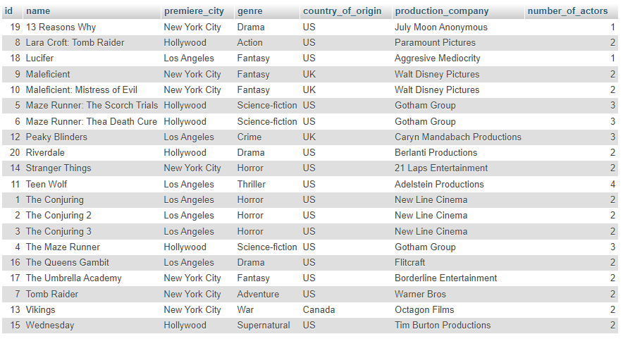

* SELECT a.*, COUNT(ma.actor_id) AS number_of_movies

FROM movie m JOIN movie_actor ma ON ma.movie_id=m.id JOIN actor a ON ma.actor_id=a.id

GROUP BY a.id;

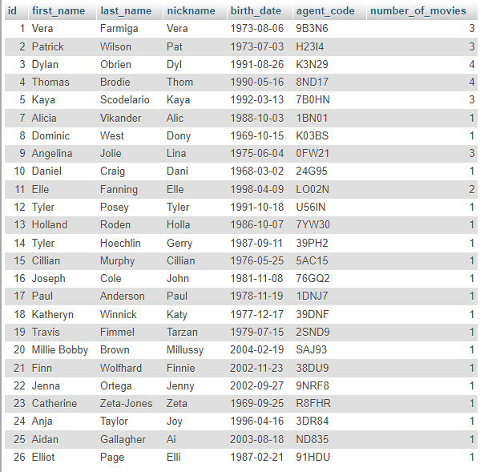

* SELECT fi.id, fi.movie_name, pc.city AS premiere_city, fi. 1week_premiere_money, fo.type AS format

FROM film fi JOIN format fo ON fi.format_id=fo.id JOIN premiere_city pc ON fi.premiere_city_id=pc.id

ORDER BY fo.type ASC;

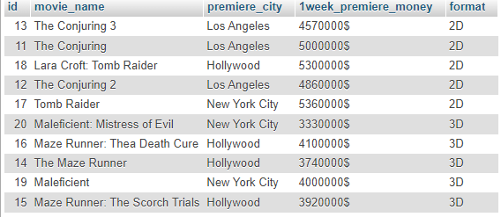

* SELECT f.movie_name, o.role, o.year, a.*

FROM film f JOIN oscar o ON o.film_id=f.id JOIN actor a ON o.actor_id=a.id

ORDER BY o.year DESC;

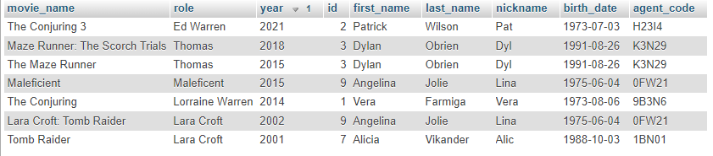

**5 points**

* SELECT f.id, f.movie_name, f.sequel, pc.city AS premiere_city, f.1week_premiere_money, fo.type AS format, CONCAT(a.first_name,' ', a.last_name) AS actors, CONCAT(d.first_name,' ', d.last_name) AS directors

FROM director d JOIN film f ON f.director_id=d.id JOIN movie m ON f.movie_name=m.name JOIN movie_actor ma ON ma.movie_id=m.id JOIN actor a ON ma.actor_id=a.id JOIN premiere_city pc ON f.premiere_city_id=pc.id JOIN format fo ON f.format_id=fo.id

ORDER BY d.first_name ASC;

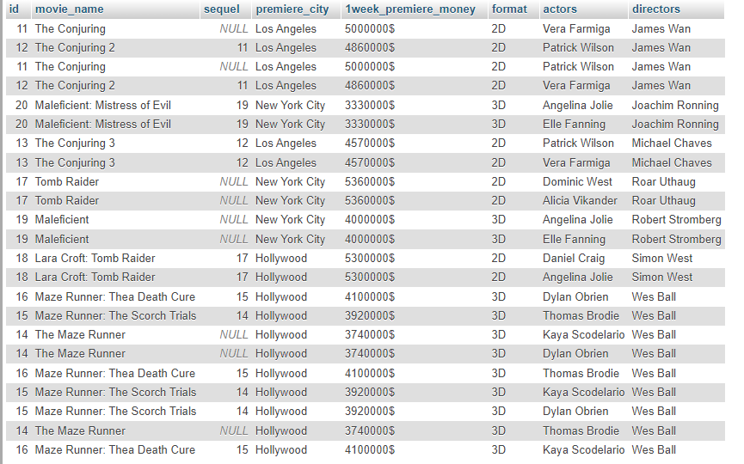

* SELECT a.*, ac.acting1_10

FROM actor a JOIN actor_critic ac ON ac.actor_id=a.id

WHERE ac.acting1_10 < (SELECT AVG(ac.acting1_10)

FROM actor a JOIN actor_critic ac ON ac.actor_id=a.id)

ORDER BY ac.acting1_10 DESC;

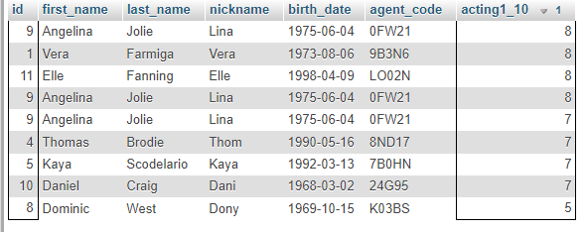

* SELECT DISTINCT a.first_name, a.last_name, a.birth_date, FLOOR(DATEDIFF(CURRENT_DATE, a.birth_date) / 365) AS age

FROM actor a JOIN oscar o ON o.actor_id=a.id

WHERE FLOOR(DATEDIFF(CURRENT_DATE, a.birth_date) / 365) > (SELECT AVG(FLOOR(DATEDIFF(CURRENT_DATE, birth_date) / 365)) FROM actor) ;

